2016 Calc-assumed:
A walking club is planning a charity walk from Perth to Esperance. They plan to walk 20 km on the first day and 30 km every day after that. Food and camping supplies are to be set up at each overnight campsite in advance, using a vehicle based in Perth that is just large enough to carry enough for one campsite.
To leave the supplies at the first campsite, the vehicle must travel 40 km. For the second and third campsites, the vehicle must travel 100 km and 160 km respectively.

c) The vehicle can travel a maximum of 700 km on one tank of fuel. Determine the number of the furthest campsite the vehicle can leave supplies at, using no more than one tank of fuel.

T_{n} = 40 + (n–1)60
T_{n} = 40 + (n–1)60 = 700
n = 12 → 12th campsite

d) If fuel costs 128 cents per litre and the fuel consumption of the vehicle is 9.5 litres per 100 km, determine the total fuel cost to set up the first 20 campsites.

S₂₀ = $\frac{20}{2}$(80 + 19 x 60) = 12200
L = $\frac{12200}{100}$ x 9.5 = 1159L
Cost = 128 x 1159 = 148352 cents = $1483.52

2016 Calc-assumed:
Records show that of the 1756 washing machines sold by a retailer during 2015, 464 were deluxe models and the rest were standard. Of all the machines sold, 42 were returned and 31 of these returned machines were standard models.

a) Determine how many of the standard models were not returned.
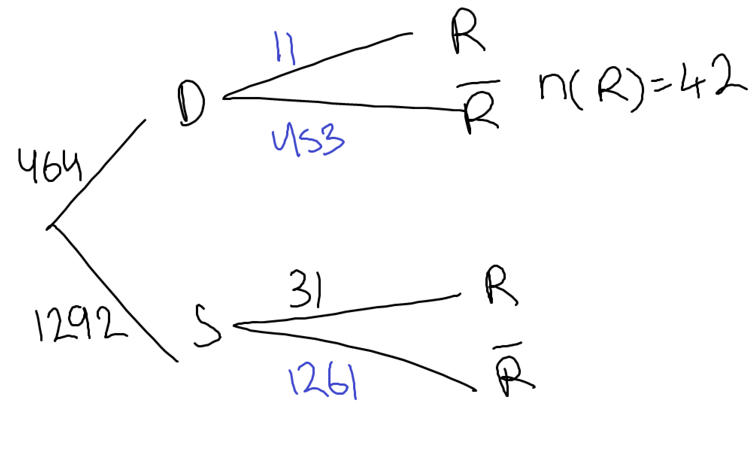
1261

b) Is there any indication that the likelihood of a machine being returned is independent of the model type? Explain your answer.

Yes
P(R) = $\frac{31+11}{1756}$ = $\frac{42}{1756}$ = $\frac{21}{878}$ = 0.02392
P(R|S) = $\frac{31}{1292}$ = 0.02399
Very similar so likely to be independent
2016 Calc-assumed:
The imprisonment rate $R$, in number of prisoners per 100 000 people, in the US between the years 1960 and 2000, can be modelled by the following equation, where $n$ is the year.

$$R=85{\left(1.038\right)}^{n-1960}$$

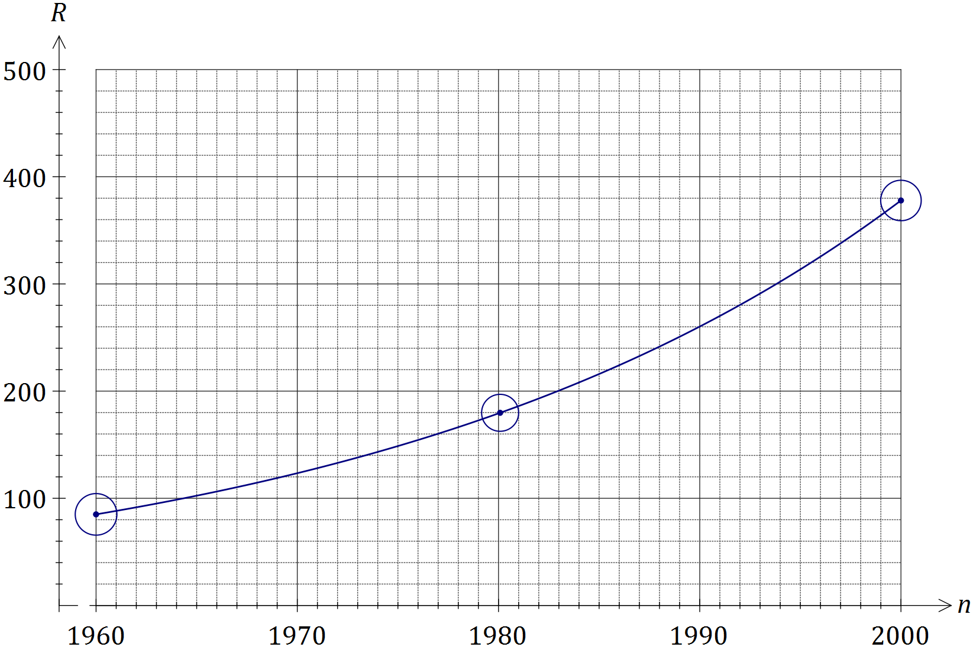

a) The population of the US was 266 million in 1995. Determine the number of prisoners in the US at this time, to the nearest 1 000.

85(1.038)^{1995–1960} = 313.56 per 100000 people
#prisoners = $\frac{313.56}{100000}$ x 226000000 = 834080 → 834000 prisoners

b) When $R$ first exceeded 500, steps were taken to address the exponential growth in the prison population and the model no longer applied. In what year did this occur.

85(1.038)^{n–1960} = 500 → n = 2007.51 → occurred during 2007

2016 Calc-assumed:
A sequence is defined by $T_{n+1}=T_{n}-7, T_{1}=111$.
Determine the value of $n$ that maximises $S_{n}$.

S_{n} = $\frac{n}{2}$(222 + (n–1)( –7))
S_{n}’ = $\frac{–(14n–229)}{2}$ → S_{n}’ = 0 → n = 16.36
S₁₅ = 930, S₁₆ = 936, S₁₇ = 935
Therefore n = 16 maximises S_{n}

2017 Calc-assumed:
The number of followers of a social media influencer, counted at the start of five successive months, is shown in the exponential graph below.

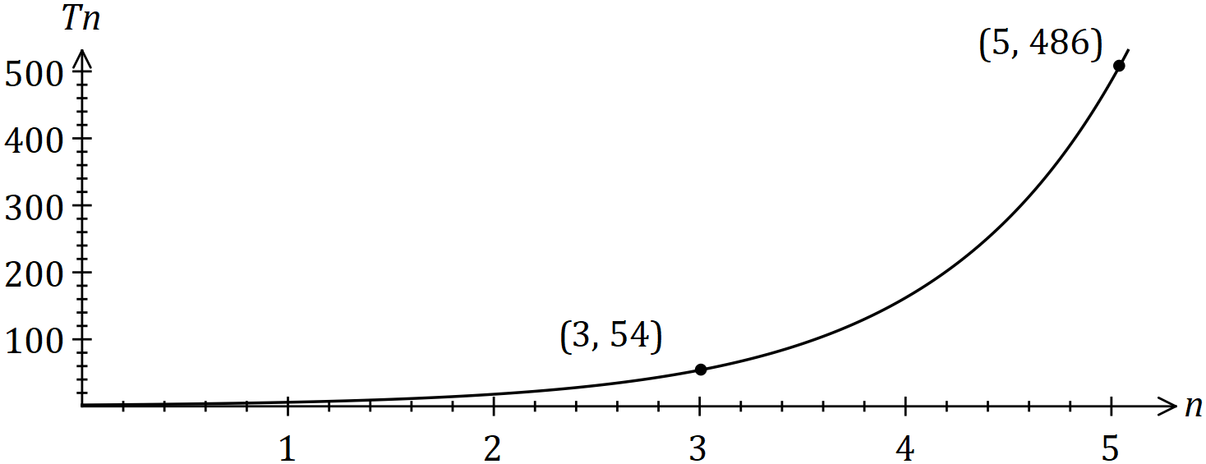

The number of followers ($T_{n}$) at the start of month $n$ can be modelled by the recursive equation $T_{n+1}=rT_{n} , T_{1}=a$.
When the number of followers reached 2 million, the influencer fell out of favour and started to lose 40% of their followers each month. After how many months from this time will they have less than 1 000 followers?

T_{n} = 2000000(0.6)^{n} = 1000 → n = 14.88
Hence after 15 months

2017 Calc-assumed:
A particle is moving along a straight line so that its displacement, $x$ metres, from a fixed point $O$ after $t$ seconds is given by
$$x=5-\frac{18t}{5}+\frac{12t^{2}}{5}-\frac{2t^{3}}{5}$$
Sketch the displacement of the particle on the axes below for $0≤t≤5$.
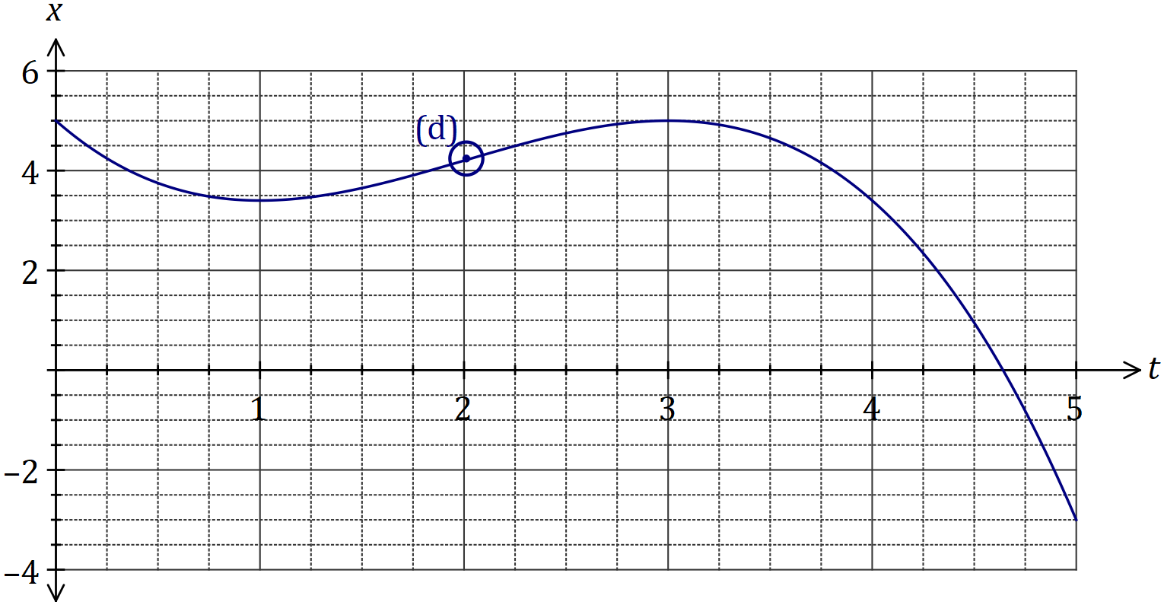
a) Determine the velocity of the particle when $t=0.5$.

x’ = $\frac{–0.2(6t^{2}–24t+18)}{5}$
x’(0.5) = –1.5ms⁻¹

b) For how long during the first five seconds is the particle is moving towards $O$.

1 + (4.625 – 3) = 2.625 seconds
c) Circle the point on the graph where the particle is moving with the maximum velocity and explain what feature of the graph you used to choose this point.

Velocity is maximum at the point where the curve has the greatest positive slope.

2017 Calc-assumed:
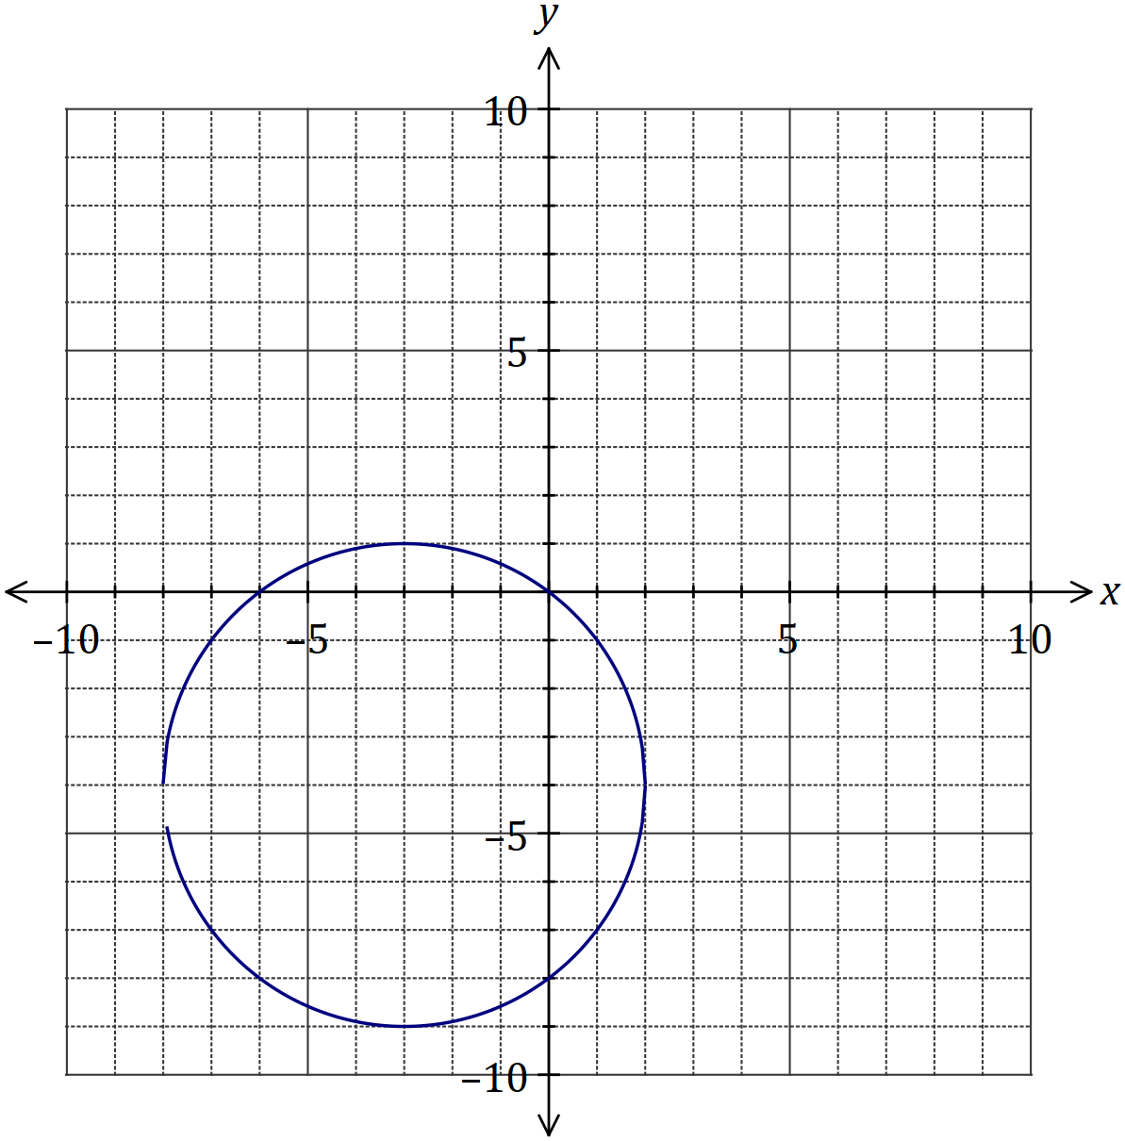
How does the vertical line test indicate that $y$ is not a function of $x$?

Any vertical line drawn from –8 < x < 2 will intersect the graph more than once, therefore it doesn’t pass the vertical line test.

2017 Calc-assumed:
Events $A$ and $B$ occur at random and it is known that $P\left(B\right)=0.6$ and $P\left(A∪B\right)=0.72$.
a) Determine $P(A)$ when $A$ and $B$ are independent.
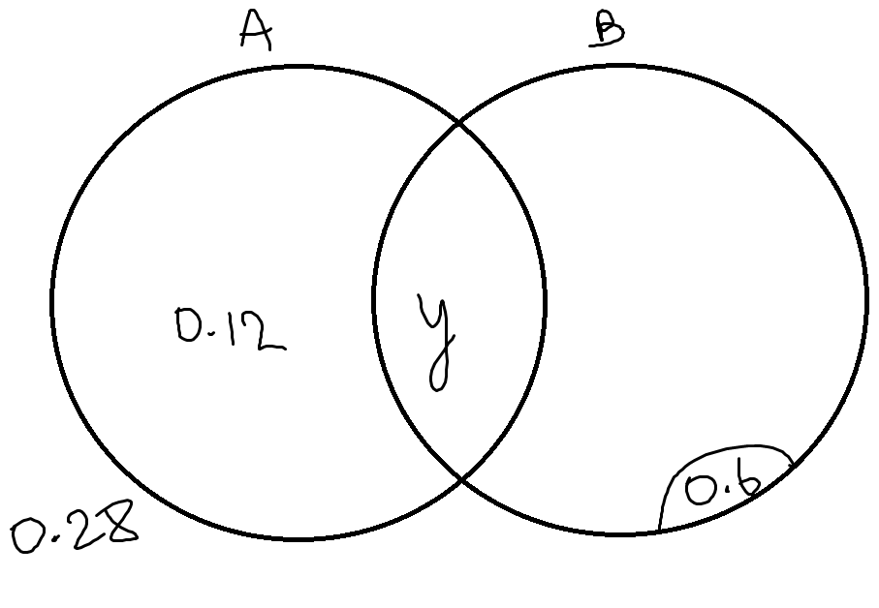
(0.12+y)0.6 = y → y = 0.18

b) Determine $P\left(B|A\right)$ if $P\left(B|\overline{A}\right)=0.65$.
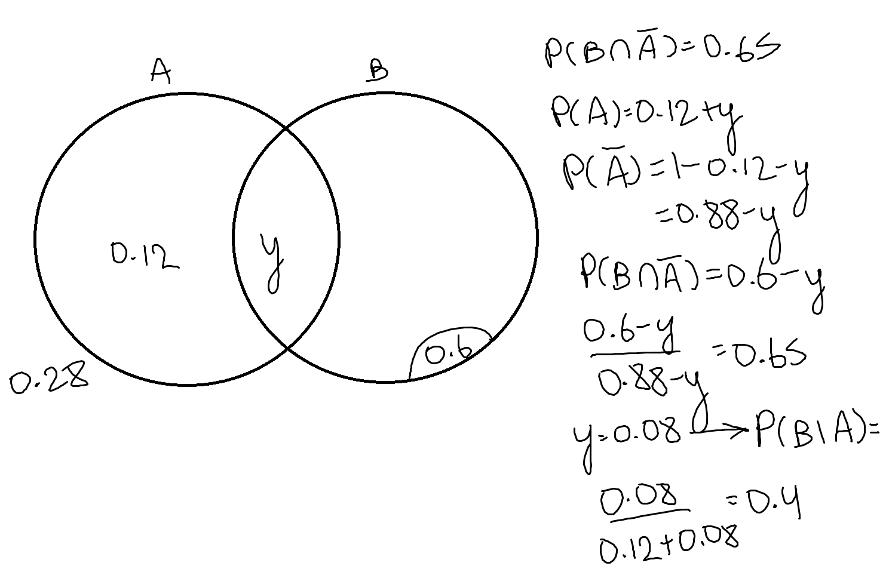
2018 Calc-free:
Let $f\left(x\right)=\begin{matrix}x \\ \overline{x+3}\end{matrix}$. The graph of $y=f(x)$ is shown below.
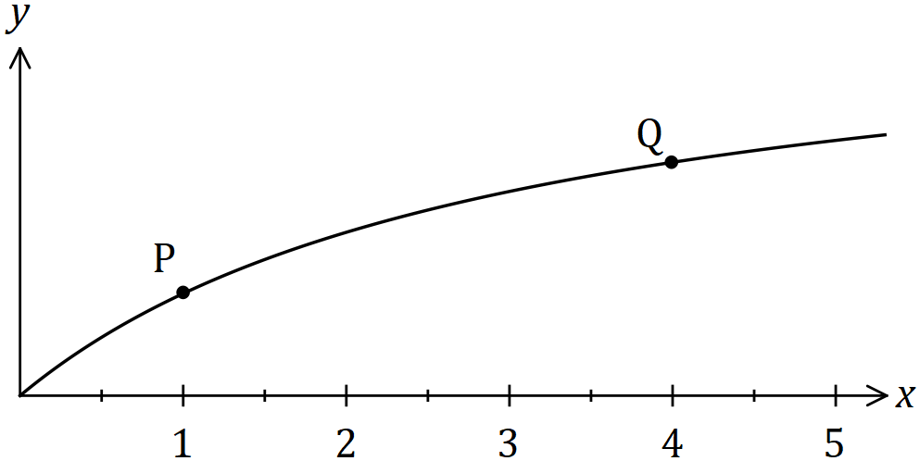
Use the formula $f^{'}\left(x\right)=\lim_{h→0}{\begin{matrix}f\left(x+h\right)-f(x) \\ \overline{ h }\end{matrix}}$ to determine the gradient of the curve at $P$.
$f^{'}\left(x\right)=\lim_{h→0}{\begin{matrix}\frac{x+h}{x+h+3}-\frac{x}{x+3} \\ \overline{ h }\end{matrix}}$ =
$\lim_{h→0}{\begin{matrix}\frac{(x+h)(x+3)-x(x+h+3)}{(x+h+3)(x+3)} \\ \overline{ h }\end{matrix}}$ =
$\lim_{h→0}{\begin{matrix}\frac{x^{2}+3x+hx+3h-x^{2}-xh-3x}{x^{2}+3x+hx+3h+3x+9} \\ \overline{ h }\end{matrix}}$ =
$\lim_{h→0}{\begin{matrix}\frac{h(x+3-x)}{x^{2}+6x+hx+3h+9} \\ \overline{ h }\end{matrix}}$ =
$\lim_{h→0}\frac{3}{x^{2}+6x+hx+3h+9}$ = $\frac{3}{x^{2}+6x+9}$ → f’(1) = $\frac{3}{1+6+9}$ = $\frac{3}{16}$

2017 Calc-free:
The graph of $y=f(x)$ is shown below, where $f\left(x\right)=\sqrt{2x+1}$.
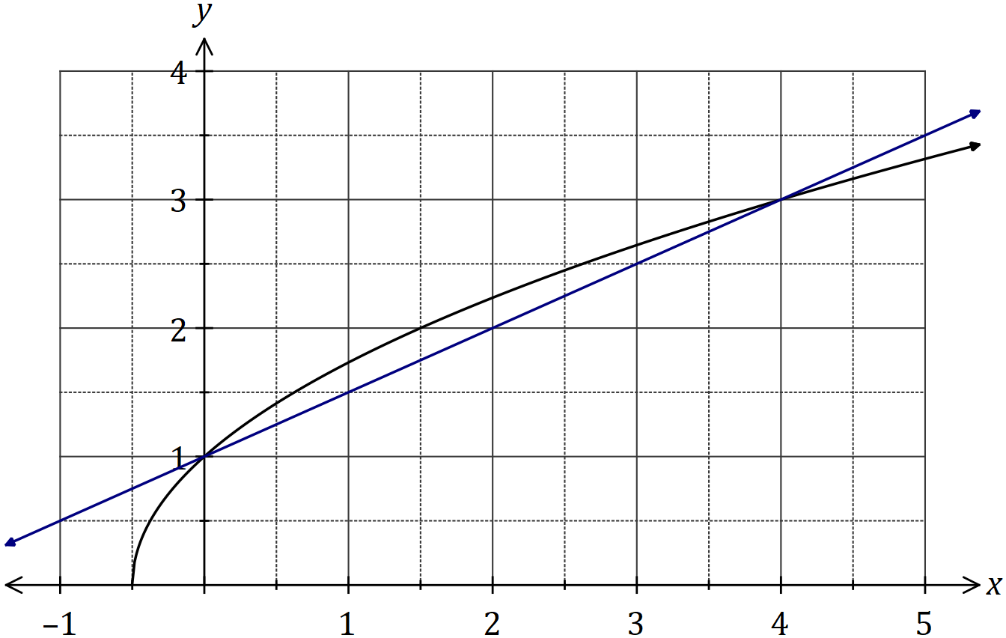
The difference quotient is shown here:
$$\frac{f\left(x+h\right)-f(x)}{h}$$

Evaluate the difference quotient as $h→0$ to determine the slope of $f(x)$ when $x=0$.

$\frac{\sqrt{2(x+h)+1}-\sqrt{2x+1}}{h}$ = $\frac{\sqrt{2x+2h+1}-\sqrt{2x+1}}{h}$
$\frac{\sqrt{2x+2h+1}-\sqrt{2x+1}}{h}$|x=0 → $\frac{\sqrt{2h+1}-\sqrt{1}}{h}$ =
$\frac{\sqrt{2h+1}-1}{h}$ x $\frac{\sqrt{2h+1}+1}{\sqrt{2h+1}+1}$ =
$\frac{2h+1-1}{h(\sqrt{2h+1}+1)}$ =
$\frac{2h}{h(\sqrt{2h+1}+1)}$ = $\frac{2}{\sqrt{2h+1}+1}$
$\frac{2}{\sqrt{2h+1}+1}$|h=0 → difference quotient = $\frac{2}{\sqrt{1}+1}$ = $\frac{2}{2}$ = 1

2016 Calc-free:
The first three terms, in order, of geometric sequence are $x-5$, $x-1$ and $2x+4$.
Determine all possible values for the fourth term of the sequence.

r = $\frac{x-1}{x-5}$ = $\frac{2x+4}{x-1}$ → (x–1)² = (2x+4)(x–5) → x² – 2x + 1 = 2x² – 10x + 4x – 20
x² – 4x – 21 = 0 → (x–7)(x+3) = 0 → x = 7, –3

x = 7 → r = $\frac{2(7) +4}{7–1}$ = $\frac{18}{6}$ = 3
x = –3 → r = $\frac{2(–3)+4}{–3–1}$ = $\frac{–2}{–4}$ = $\frac{1}{2}$

x = 7 → T₄ = (2(7) + 4)(3) = (14 + 4)(3) = 18 x 3 = 54
x = –3 → T₄ = (2(–3) + 4)($\frac{1}{2}$) = $\frac{1}{2}$(–6 + 4) = $\frac{1}{2}$(–2) = –1
T₄ = 54, T₄ = –1

2018 Calc-assumed:
The temperature $T$ of a cast taken out of an oven cools according to the model $T=840{\left(0.94\right)}^{t}$, where $t$ is the time in minutes since the cast was removed from the oven. $T$ is measured in $°C$.
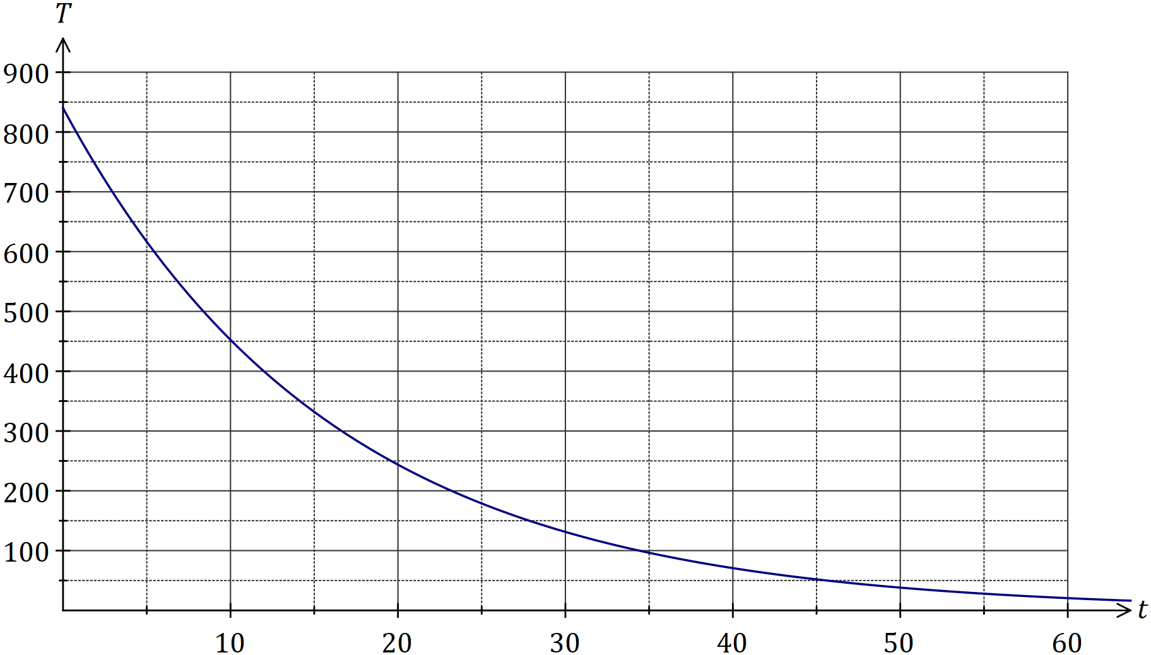
The temperature of the cast falls to room temperature of$15°C$.
a) Determine the time taken for the cast to reach room temperature.

$840{\left(0.94\right)}^{t}$ = 15 → t = 65.06 minutes

b) Comment on the usefulness of the model for large values of $t$.

For large values of $t$ the model shows that $T→0$ but the temperature of the cast only falls to $15°C$ and so model not valid for large $T$.

2018 Calc-assumed:
Two water containers, initially empty, are being filled with water. The amount of water added to container $A$ each minute follows an arithmetic sequence, with $3$ mL poured in during the first minute and $6$ mL poured in during the second minute. The amount of water added to container $B$ each minute follows a geometric sequence, with $2$ mL poured in during the first minute and $2.2$ mL poured in during the second minute.
Container $B$ first holds more water than container $A$ at the end of minute $m$.
a) Determine the value of $m$.

$\frac{n}{2}$(6 + (n–1)3) = $\frac{2(1–1.1^{n})}{1–1.1}$ → n = 58.38 → 59 minutes

b) State, to the nearest mL, how much more water $B$ contains than $A$ at this time.

B: S₅₉ = $\frac{2(1–1.1^{59})}{1–1.1}$ = 5516
A: S₅₉ = $\frac{59}{2}$(6 + (n–1)3) = 5310
5516 – 5310 = 206mL

2018 Calc-assumed:
A diagnostic test for a disease has a $97\%$ chance of giving the correct outcome and it is known that $0.5\%$ of all sheep on a station have the disease. It can be assumed that the correct outcome of the test is independent of whether a sheep has the disease.
a) A sheep is randomly selected for the test from those on the station. Determine the probability that:
i) the sheep has the disease, but the test indicates that it does not.
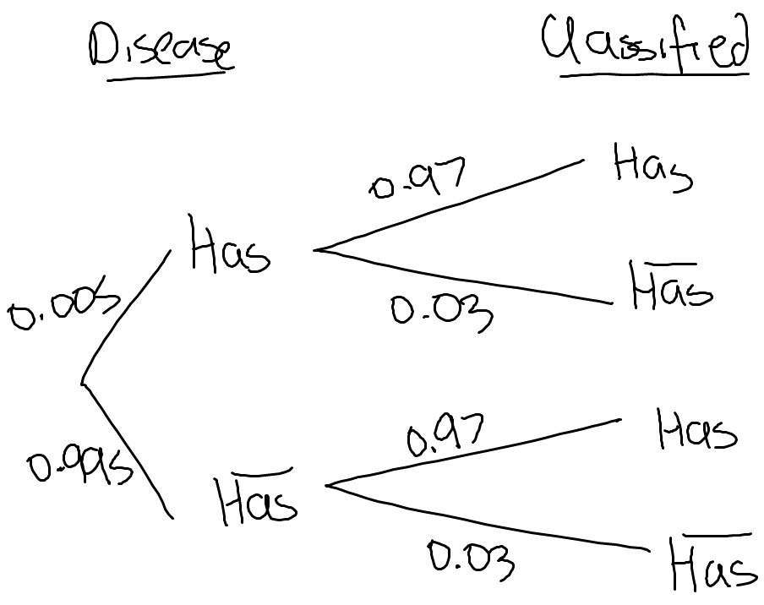
0.005 x 0.03 = 0.00015

ii) the sheep actually has the disease if the test indicates that it does.

$\frac{(0.005)(0.97)}{(0.995)(0.03)+(0.005)(0.97)}$ = 0.140

b) Two sheep are randomly selected for the test from those on the station. Determine the probability that just one of the sheep is diagnosed correctly.

0.97 x 0.03 x 2 = 0.0582

2019 Calc-assumed:
A drone is flying in a straight line and at a constant height $h$ m above a level pitch towards a thin goal post. It maintains a constant speed of $4.5$ ms⁻¹.
Initially, the angle of depression from the drone to the base of the post is $8°$. Exactly $3$ seconds later this angle has increased to $10°$.
a) Sketch a diagram to show the two angles of depression from the drone to the base of the post.
z
13.5m

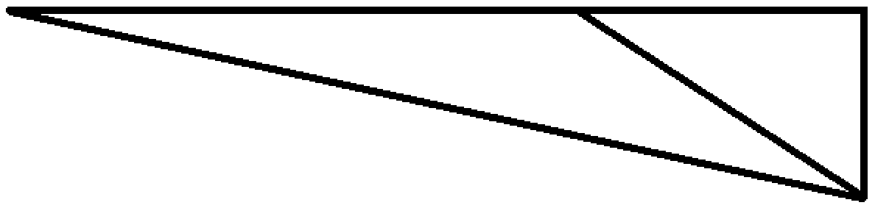
2°
170°
y
h
8°
10°

b) Determine, showing all working, the value of $h$ and calculate the time after leaving its initial position that the drone will collide with the post.

$\frac{13.5}{sin2}$ = $\frac{y}{sin8}$ → y = 53.84m

sin10 = $\frac{h}{53.84}$ → h = 9.35m

cos10 = $\frac{z}{53.84}$ → z = 53.02

t = 3 + $\frac{53.02}{4.5}$ = 14.78 seconds

2019 Calc-assumed:
A geometric sequence has a second term of $-2.5$ and a sum to infinity of $8$.
Determine the sum of the first $3$ terms of the sequence.
$\frac{\frac{-2.5}{r}}{1-r}$ = 8 → r = –0.25, 1.25

reject r = 1.25 since |r| < 1

r = –0.25 → a = $\frac{–2.5}{–0.25}$ = 10

S₃ = $\frac{10(1+0.{25}^{3})}{1+0.25}$ = 8.125

2019 Calc-assumed:
The function $f$ is defined by $f(x)=x^{3}-2x^{2}-4x+8$, where $a, b$ and $c$ are constants.

The graph of $y=f(x)$ has the following features:
- Passes through $(0, 8)$ and $(-2, 0)$
- Has a local minimum at $(2, 0)$
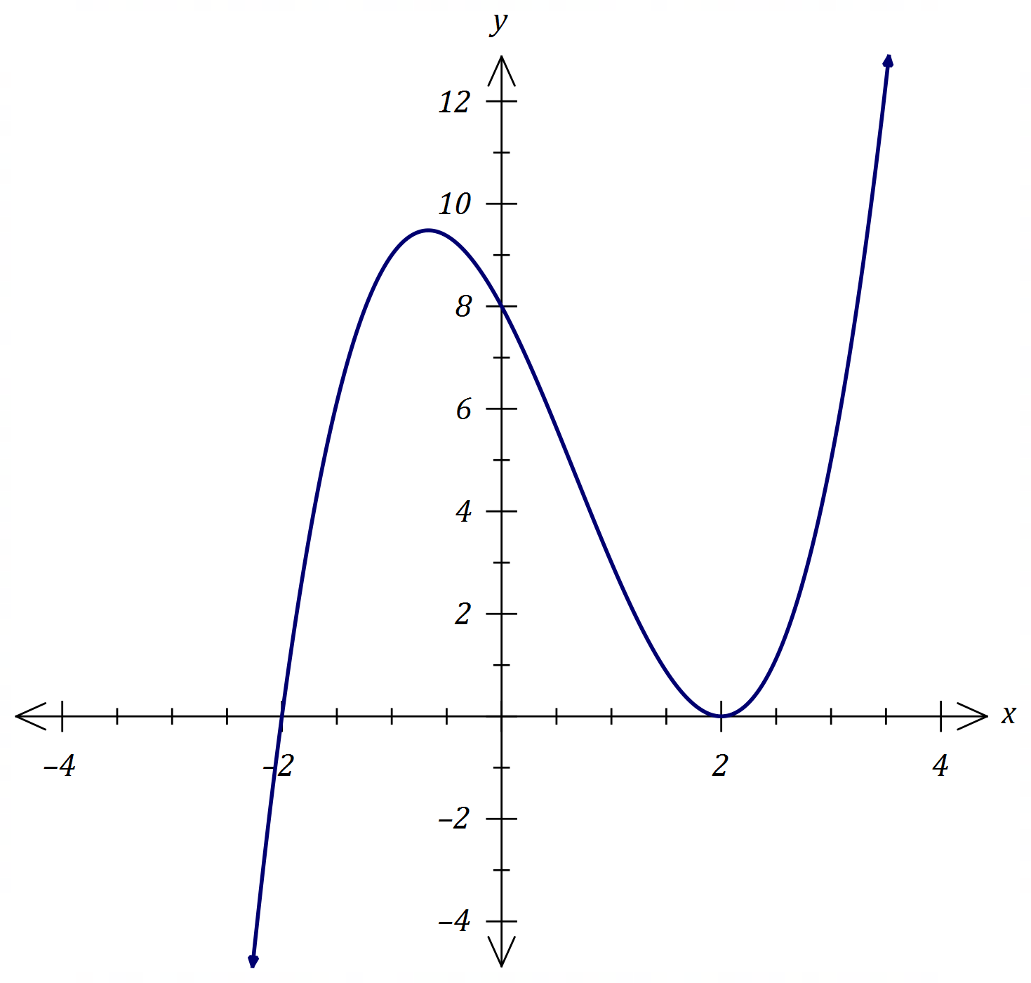
Determine the coordinates of the point where the tangent to $y=f(x)$ at $(0, 8)$ intersects the curve $y=f(x)$, other than at the point of tangency.

f(x) = $x^{3}-2x^{2}-4x+8$

f’(x) = 3x² – 4x – 4 → f’(0) = –4 → y = –4x + c

f(0) = 8 → c = 8 → y = –4x + 8

$x^{3}-2x^{2}-4x+8$ = –4x + 8 → x = 0, 2

f(2) = 0 → intersects at (2, 0)

2019 Calc-assumed:
When a patient takes a painkilling drug $A$, the probability that they experience some side effects is known to be $0.1$.
a) A doctor prescribes drug $A$ to two unrelated patients. Determine the probability that:
i) neither patient experiences some side effects.

0.9² = 0.81

ii) one patient experiences some side effects, and the other does not.

0.9 x 0.1 x 2 = 0.18

Other painkilling drugs are available. Of those who take drug $A$, $88\%$ of patients who suffer some side effects will switch to another drug whereas no patient who has no side effects will switch.
b) The doctor prescribes drug $A$ to a patient. Determine the probability that the patient does not switch to another drug.

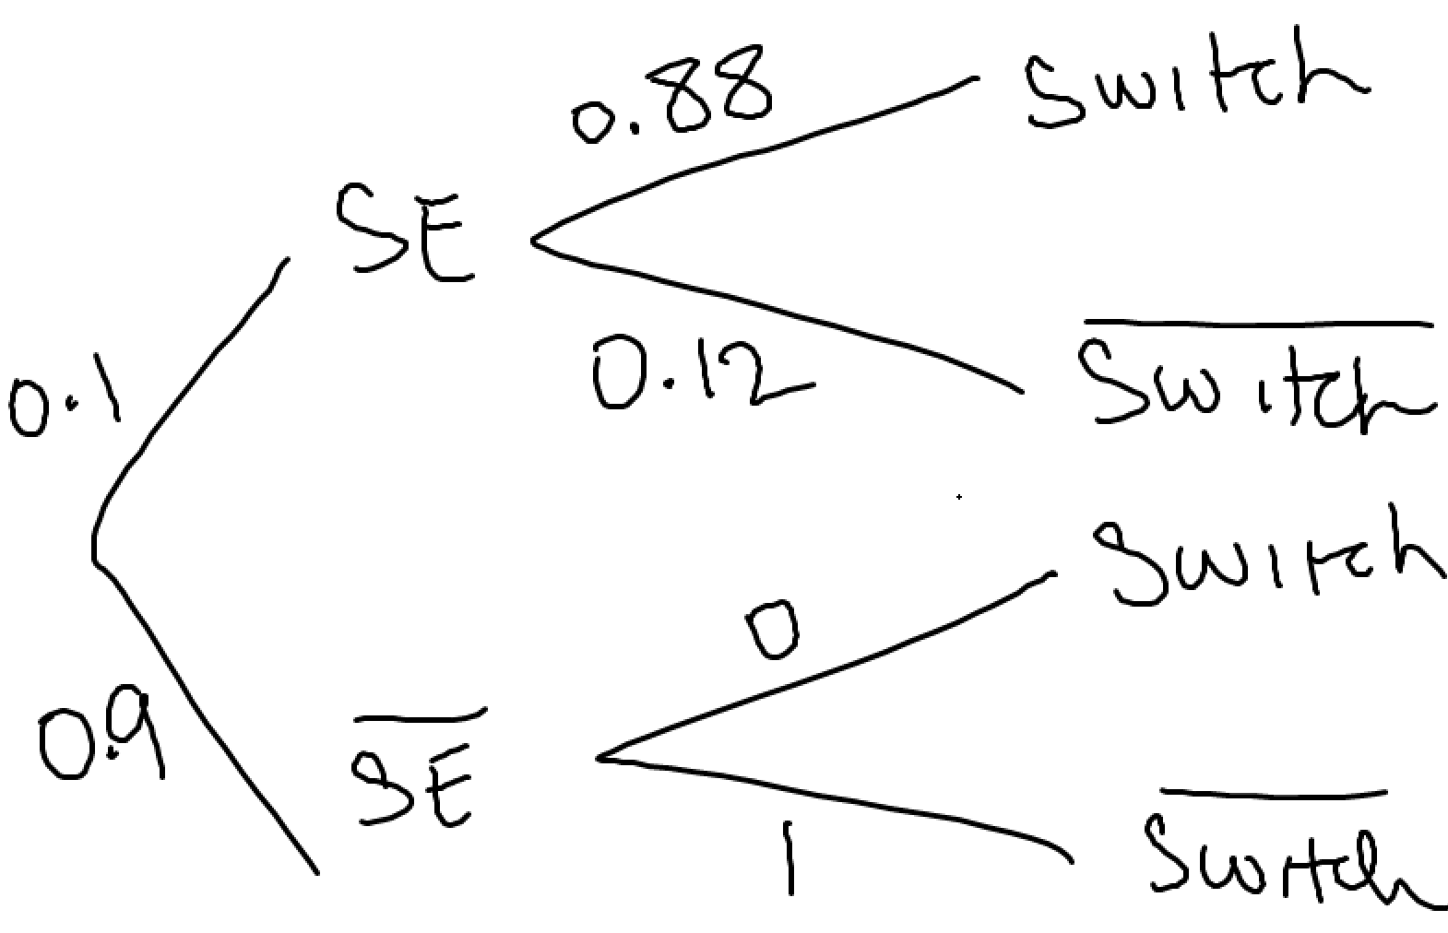
P(switch’) = (0.9)(1) + (0.12)(0.1) = 0.912

c) The doctor prescribes drug $A$ to three unrelated patients. Determine the probability that at least one of these patients switch to another drug.

P(none) = 0.912³ = 0.759
P(at least one) = 1 – 0.759 = 0.241

2019 Calc-assumed:
A fair six-sided dice numbered $1, 2, 3, 4, 5$ and $6$ is thrown $n$ times until it lands on a $6$.
a) Determine the probability that the first $6$ is thrown in $12$ or less attempts.

P_{n} = $(\frac{5}{6})^{n–1}$($\frac{1}{6}$) → a = $\frac{1}{6}$ , r = $\frac{5}{6}$
S₁₂ = $\frac{\frac{1}{6}(1–(\frac{5}{6})^{12})}{1 – \frac{5}{6}}$ = 0.888

b) The probability that the first $6$ is thrown in $k$ or less attempts must be at least $99\%$. Determine the least value of integer k.

$\frac{\frac{1}{6}(1–(\frac{5}{6})^{k})}{1 – \frac{5}{6}}$ = 0.99 → k = 25.26 → k = 26

2019 Calc-free:
Solve the following equations:
a) $\tan{(2x)}=\sqrt{3}$, $0≤x≤π$.

2x = $\frac{π}{3}$, $\frac{4π}{3}$ → x = $\frac{π}{6}$, $\frac{2π}{3}$

b) $2\cos{(x-60°)}=\sqrt{3}+\cos{x}$, $0°≤x≤360°$.

2(cos(x)cos(60) + sin(x)sin(60)) = $\sqrt{3}$ + cos(x)

2cos(x)$\frac{1}{2}$ + 2sin(x)$\frac{\sqrt{3}}{2}$ = $\sqrt{3}$ + cos(x)

cos(x) + sin(x)$\sqrt{3}$ = $\sqrt{3}$ + cos(x)

sin(x)$\sqrt{3}$ = $\sqrt{3}$ → sin(x) = 1 → x = 90°

2019 Calc-free:
The graph of $y=\sin{(ax+b)}$ is shown below, where $a$ and $b$ are positive constants.
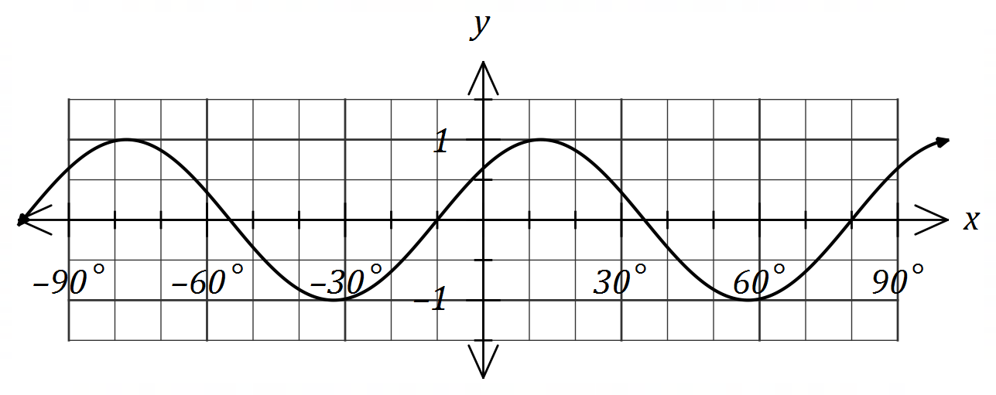
Determine the minimum possible value of each of the constants.
a = 4
$\frac{b}{4}$ = 10 → b = 40°

Note: Use discriminant to prove there are no solutions if you can’t factorise.

2015 A Calc-free:

y = x² – 3x – 18 = (x–6)(x+3) = 0 → x = 6, –3
y’ = 2x – 3 y’(6) = 12 – 3 = 9
y’(–3) = –6–3 = –9
Gradient = 9 or –9

2015 A Calc-free
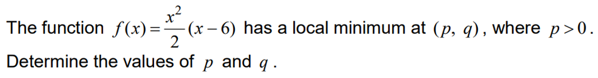
f(x) = $\frac{x^{3}}{2}$ – 3x² → f’(x) = $\frac{{3x}^{2}}{2}$ – 6x → f’(x) = 0

3x² – 12x = 3x(x – 4) = 0 → x = 0, 4 → x = 4 (reject x = 0 since x > 0)

f’’(x) = 3x – 6

f’’(4) = 12 – 6 = 6 → minimum turning point

p = 4

f(4) = 8(4–6) = 32 – 48 = –16 → q = –16

2015 A Calc-assumed:
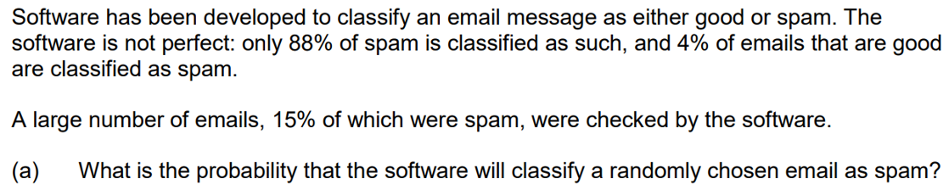
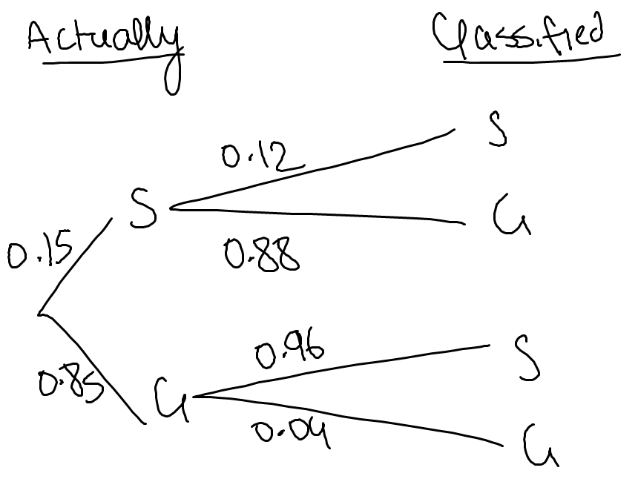
P(classified S) = (0.15)(0.88) + (0.85)(0.04) = 0.166

P(classified G) = 1 – 0.166 = 0.834
P(actually S ∩ classified G) = (0.15)(0.12) = 0.018
P(actually S | classified G) = $\frac{0.018}{0.834}$ = 0.0216

2015 A Calc-assumed:
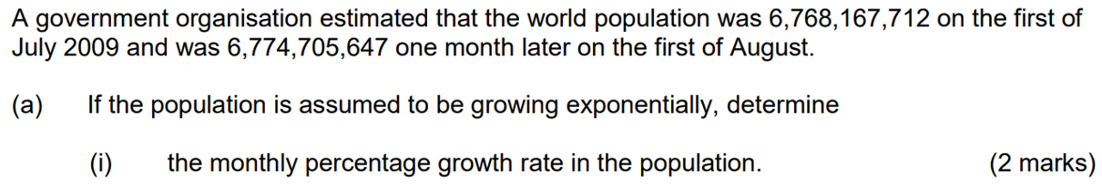
$6774705647–6768167712$ = 6537935
$\frac{6537935}{6774705647}$ x 100 = 0.0965% growth

r = $\frac{6774705647}{6768167712}$ = 1.000965
T_{n} = $6768167712$(1.000965)^{t}

T₁₂ = 6847041102 = 8647000000

2015 A Calc-assumed:

25
15

ϕ
θ
25

25
15

15² = 2(25²) – 2(25²)cosθ → θ = 0.609 radians → 2 x 0.609 = 1.219
A₁ = $\frac{1}{2}$(25²)1.219 – $\frac{1}{2}$(25²)sin1.219 = 87.53cm²

25² = 15² + 25² – 2(15)(25)cosϕ → ϕ = 1.266 radians → 2 x 1.266 = 2.532
A₂ = $\frac{1}{2}$(15²)2.532 – $\frac{1}{2}$(15²)sin2.532 = 367.47cm²

Area = A₁ + A₂ = 308.01cm²

2015 B Calc-free:
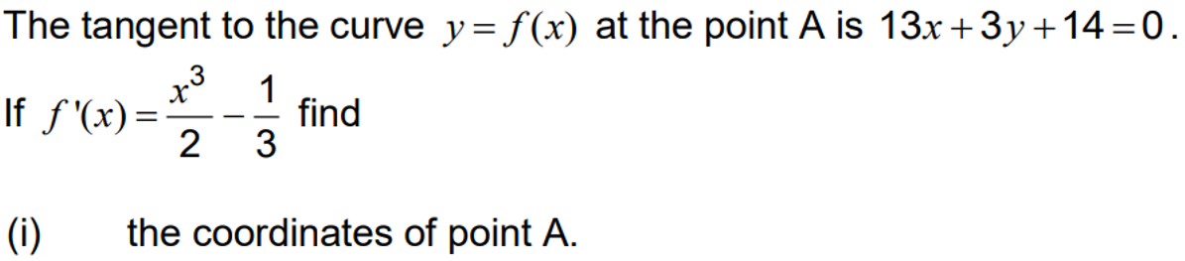

Tangent: y = $–\frac{13}{3}$x – $\frac{14}{3}$ → gradient = $–\frac{13}{3}$

f’(x) = $\frac{x^{3}}{2}$ – $\frac{1}{3}$ = $–\frac{13}{3}$ → $\frac{x^{3}}{2}$ = $–\frac{12}{3}$ → x³ = –8 → x = –2

f(–2) = $\frac{26}{3}$ – $\frac{14}{3}$ = $\frac{12}{3}$ = 4 → P(A): (–2, 4)

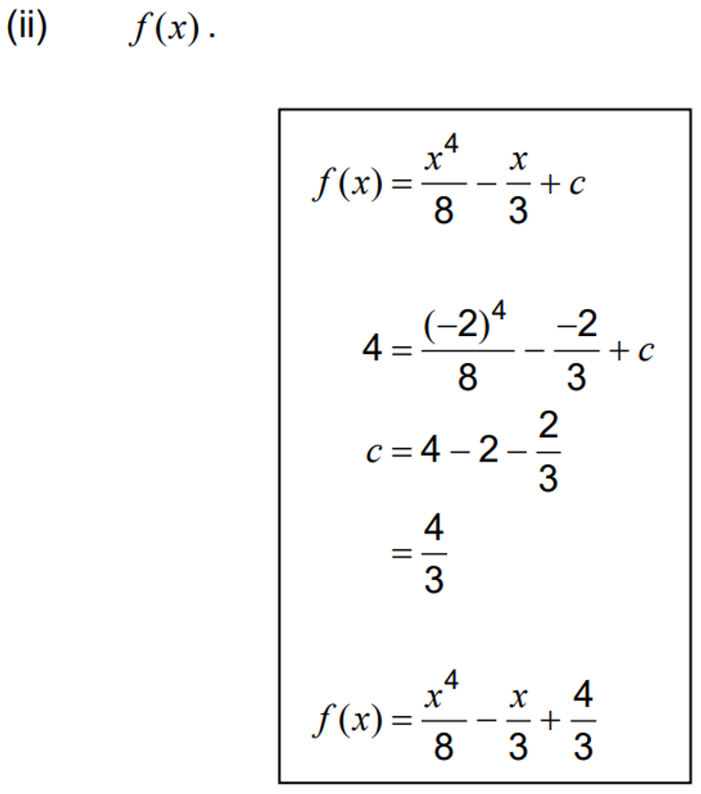
$\int{\frac{x^{3}}{2}}–\frac{1}{3}$ dx = $\frac{x^{4}}{8}$ – $\frac{x}{3}$ + c → f(–2) = 4 → 4 = 2 + $\frac{2}{3}$ + c → c = 2 – $\frac{2}{3}$ = $\frac{4}{3}$

f(x) = $\frac{x^{4}}{8}$ – $\frac{x}{3}$ + $\frac{4}{3}$

2015 B Calc-assumed:
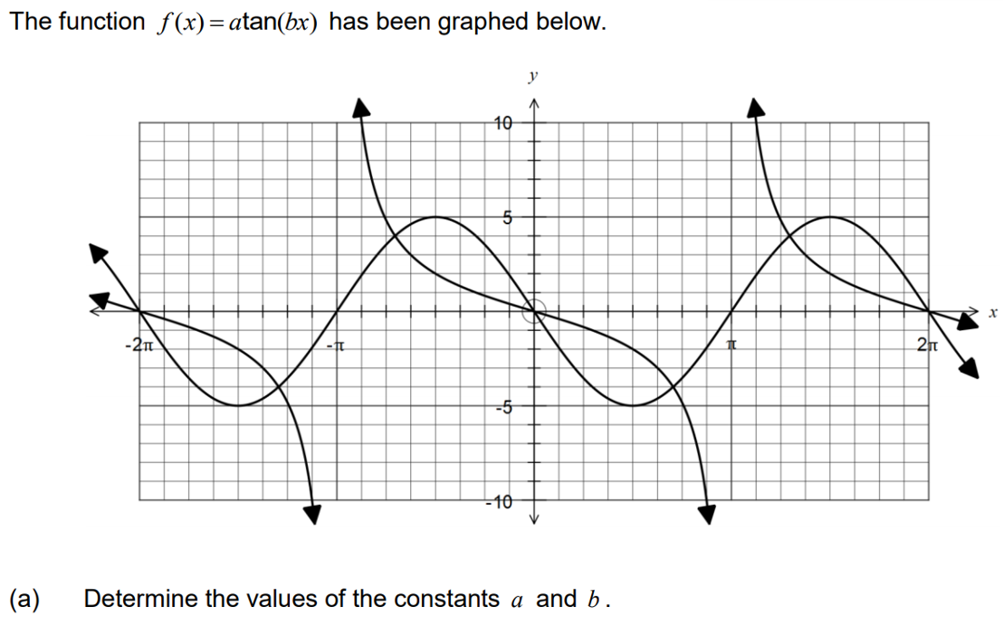
b = $\frac{1}{2}$
($\frac{π}{2}$ , –2) → –2 = a tan($\frac{1}{2}$ x $\frac{π}{2}$)
–2 = a tan($\frac{π}{4}$) → a = –2

OR:
b = $–\frac{1}{2}$
($\frac{π}{2}$ , –2) → –2 = a tan($–\frac{1}{2}$ x $\frac{π}{2}$)
–2 = a tan($–\frac{π}{4}$) → a = 2

2015 B Calc-assumed:
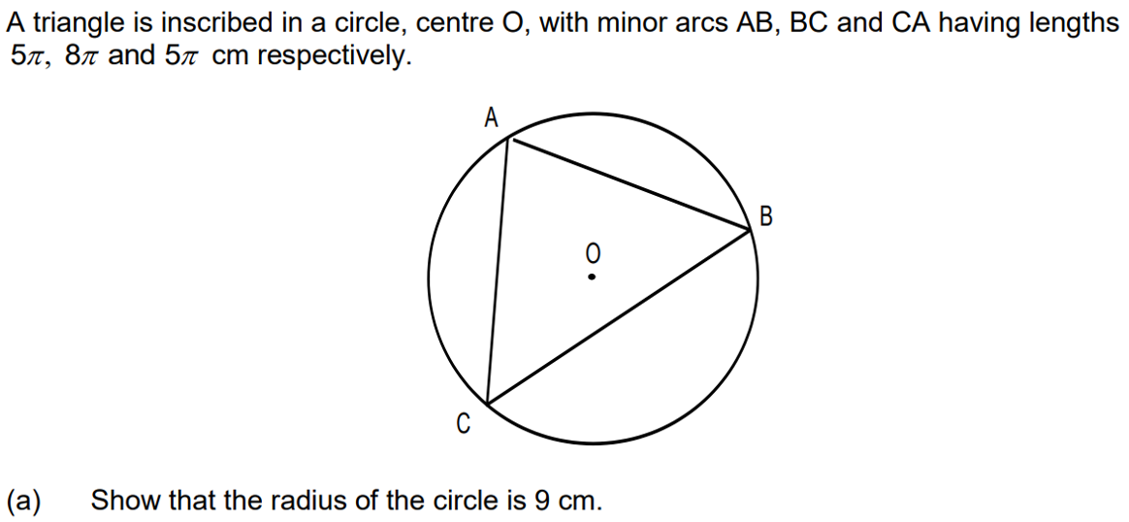
ϕ
θ
5π
8π
5π
2πr = 18π → r = 9cm

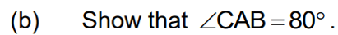

9θ = 8π → θ = $\frac{8π}{9}$ radians = 160°

∠COA = $\frac{360 – 160}{2}$ = 100°

CA² = 2(9²) – 2(i²)cos100 → CA = 13.79

$\frac{sin100}{13.79}$ = $\frac{sinϕ}{9}$ → ϕ = 40.0°

∠CAO = 2 x 40.0 = 80°

$\frac{1}{2}$(13.79²)sin80 = 93.62cm²

2016 B Calc-assumed:
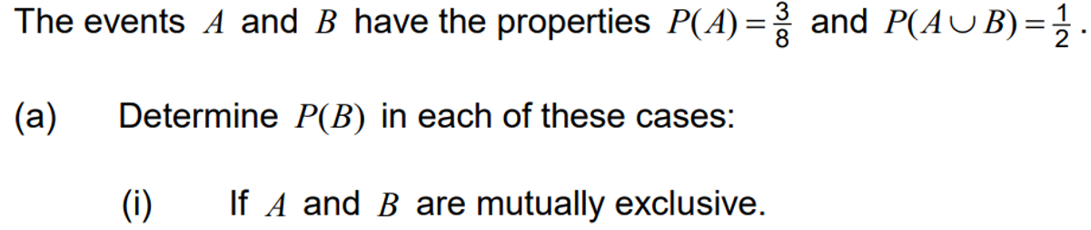
$\frac{1}{2}$ – $\frac{3}{8}$ = $\frac{1}{8}$

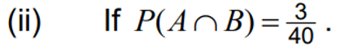

$\frac{3}{8}$ + P(B) – $\frac{1}{2}$ = $\frac{3}{40}$ → P(B) = $\frac{1}{5}$

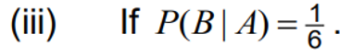

$\frac{P(B∩A)}{\frac{3}{8}}$ = $\frac{1}{6}$ → P(B∩A) = $\frac{1}{16}$
P(A’∩B) = $\frac{1}{2}$ – $\frac{3}{8}$ = $\frac{1}{8}$
B
A

$$\frac{1}{8}$$
$$\frac{1}{16}$$

$$\frac{1}{2}$$

P(B) = P(A∩B) + P(A’∩B) = $\frac{1}{16}$ + $\frac{1}{8}$ = $\frac{3}{16}$

$$\frac{3}{40}$$
B
A

P(A) = $\frac{3}{8}$ – $\frac{3}{40}$ = $\frac{3}{10}$ P(B) = $\frac{1}{2}$ – $\frac{3}{40}$ – $\frac{3}{10}$ = $\frac{1}{8}$
$$\frac{1}{8}$$
$$\frac{1}{2}$$
$$\frac{3}{10}$$

P(A) x P(B) = ($\frac{3}{40}$ + $\frac{3}{10}$)($\frac{3}{40}$ + $\frac{1}{8}$) = $\frac{3}{40}$

Hence independent since P(A∩B) = P(A) x P(B)

2015 C Calc-assumed:
Two independent events A and B are such that P(A ∩ B) = 0.2 and P(B’) = 0.6.
a) Calculate:
i) P(A)

0.2 = 0.4 x P(A) → P(A) = 0.5

ii) P(A ∪ B)

0.5 + 0.4 – 0.2 = 0.7

iii) P(B’ | A’ ∪ B’)

0.6

b) A third event, C, is complementary with event A.
What is the maximum possible value of P(C ∪ B)?

P(C) = 1 – P(A)
P(C∪B) = 0.4 + (1–0.5) – 0.2 = 0.7

2015 C Calc-assumed:
A store accepts credit card payments from customers using American Express, Mastercard or VISA cards. Records indicate that 65% of customers use a credit card, and of these customers, 20% use American Express, 35% Mastercard and the rest VISA. Further analysis shows that the male to female ratio for users of each type of card is 5:3 for American Express, 2:3 for Mastercard and 3:2 for VISA.

a) Calculate the probability that a randomly selected customer from the records will be a female who uses an American Express credit card.

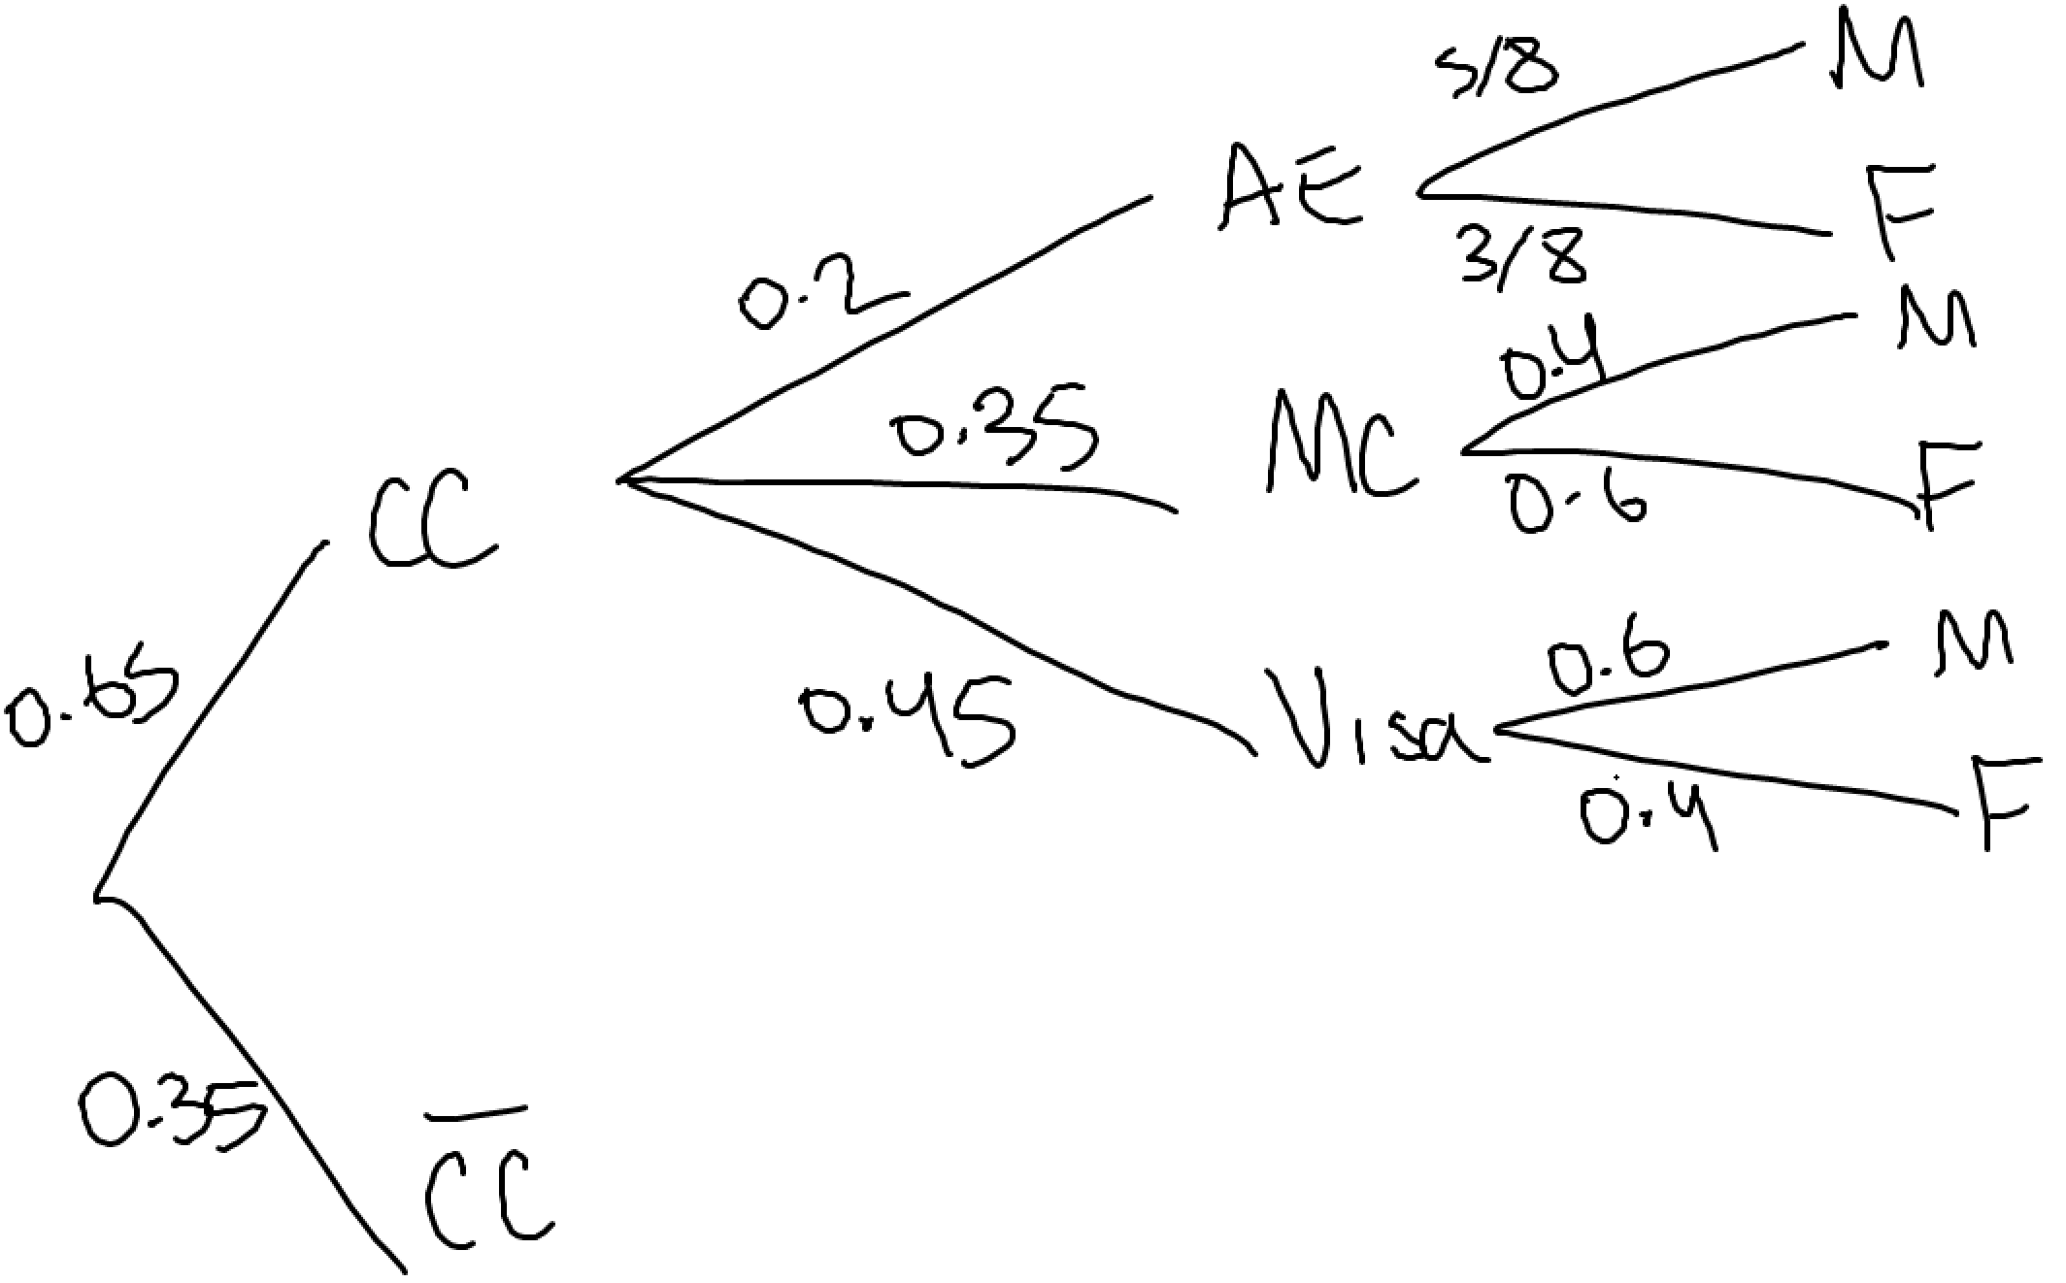
(0.65)(0.2)($\frac{5}{8}$) = 0.08125

b) Given that a randomly selected customer used a credit card, what is the probability that they are male.

$\frac{P(CCM)}{P(CC)}$ = $\frac{(0.65)(0.2)(\frac{5}{8})+(0.65)(0.35)(0.4)+(0.65)(0.45)(0.6)}{0.65}$ = 0.535

c) What is the probability that a randomly selected female customer who used a credit card used a VISA card.

$\frac{P(CCVisaF)}{P(CCF)}$ = $\frac{(0.65)(0.45)(0.4)}{(0.65)(0.2)(\frac{3}{8})+(0.65)(0.35)(0.6)+(0.65)(0.45)(0.4)}$ = 0.387

2015 C Calc-assumed:
The diagram shows five congruent semicircles standing on the inside of a regular pentagon with sides of length 20 cm. M is the midpoint of the side AB and P is the point of intersection of two semi-circles.
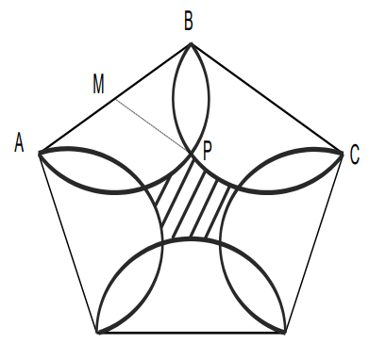
θ

a) Show that the size of angle ∠BMP = 72°.
B

θ

2cm
2cm

C
M

P

r = BM = 2cm
θ = $\frac{540}{5}$ = 108°
∠BMP = $\frac{360–2(108)}{2}$ = 72°

b) Determine the area of the central shaded region.

Area(1 segment) = $\frac{1}{2}$(2²)$\frac{72π}{180}$ – $\frac{1}{2}$(2²)sin($\frac{72π}{180}$) = 0.611cm²

Area(semicircle) – area(4 segments) = $\frac{1}{2}π2$² – 4(0.611) = 3.84cm²

Area(pentagon) = $\frac{–900sin\frac{2π}{5})}{5cos(\frac{2π}{5})–5}$ = 247.75cm²

Area(shaded) = 247.75 – 5(3.84) – 5(0.611) = 225.50cm²

2019 Calc-assumed:
A right circular cone of base radius $10$ cm and height $25$ cm stands on a horizontal surface. A cylinder of radius $x$ cm and volume $V$ cm³ stands inside the cone with its axis coincident with that of the cone and such that the cylinder touches the curved surface of the cone as shown.

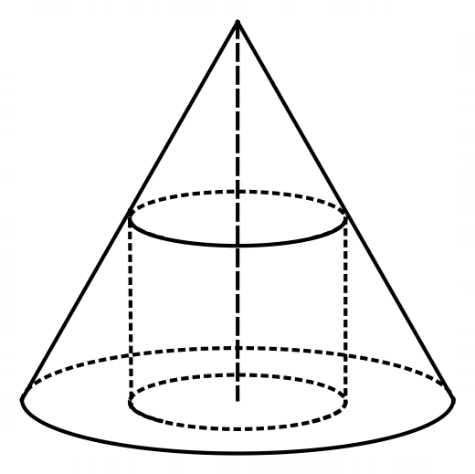
Show that $V=25πx^{2}-2.5πx^{3}$.

25

h

θ
10

$$10–x$$
x

tanθ = $\frac{25}{10}$ = $\frac{h}{10–x}$ → h = $\frac{25(10–x)}{10}$ = $\frac{250–25x}{10}$ = 25 – 2.5x

V = πx²h = πx²(250 – 2.5x) = $25πx^{2}-2.5πx^{3}$
Use an appropriate derivative to evaluate $\lim_{h→0}{[ \frac{(1+\sqrt{5+h}-(1+\sqrt{5})^{2}}{h}}$]
$\lim_{h→0}{[ \frac{(1+\sqrt{5+h}-(1+\sqrt{5})^{2}}{h}}$] = $\frac{d}{dx}(1+\sqrt{x})^{2}$|x=5 = $2\left(1+\sqrt{x}\right) x \frac{1}{2\sqrt{x}}$|x=5 = $\left(1+\sqrt{5}\right) x \frac{1}{\sqrt{5}}$ = $\frac{1+\sqrt{5}}{\sqrt{5}}$ = 1 + $\frac{\sqrt{5}}{5}$

